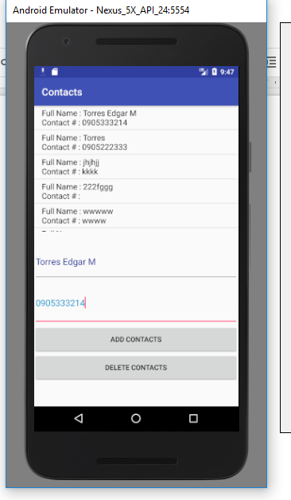

XML Files

*<?***xml version="1.0" encoding="utf-8"***?>*

<**RelativeLayout xmlns:android="http://schemas.android.com/apk/res/android"**

**xmlns:tools="http://schemas.android.com/tools"**

**android:id="@+id/activity_list_order"**

**android:layout_width="match_parent"**

**android:layout_height="match_parent"**

**android:paddingBottom="@dimen/activity_vertical_margin"**

**android:paddingLeft="@dimen/activity_horizontal_margin"**

**android:paddingRight="@dimen/activity_horizontal_margin"**

**android:paddingTop="@dimen/activity_vertical_margin"**

**tools:context="com.example.chanel.milkteaorderapps.ListOrderActivity"**>

<**ListView**

**android:layout_width="wrap_content"**

**android:layout_height="wrap_content"**

**android:id="@+id/listView"**

**android:layout_alignParentTop="true"**

**android:layout_centerHorizontal="true"**

**android:layout_above="@+id/txtTotalPrice"** />

<**TextView**

**android:layout_width="wrap_content"**

**android:layout_height="wrap_content"**

**android:textAppearance="?android:attr/textAppearanceLarge"**

**android:text="Total Amount: Php 0.00"**

**android:id="@+id/txtTotalPrice"**

**android:layout_alignParentBottom="true"**

**android:gravity="center_vertical|center_horizontal"**

**android:paddingTop="10dp"**

**android:paddingBottom="10dp"**

**tools:ignore="HardcodedText"**

**android:textAlignment="center"** />

</**RelativeLayout**>

MainActivity.java

**package** com.torres.edgar.contacts;

**import** com.sqlitelib.DataBaseHelper;

**import** com.sqlitelib.SQLite;

**import** android.database.Cursor;

**import** android.database.sqlite.SQLiteDatabase;

**import** android.support.v7.app.AppCompatActivity;

**import** android.os.Bundle;

**import** android.view.View;

**import** android.widget.ArrayAdapter;

**import** android.widget.Button;

**import** android.widget.EditText;

**import** android.widget.ListView;

**public class** MainActivity **extends** AppCompatActivity {

Button **btnAdd**,**btnDelete**;

EditText **txtFullname**,**txtContacts**;

ListView **lstviewContacts**;

ArrayAdapter **adapterContacts**;

**private** DataBaseHelper **dbhelper** = **new** DataBaseHelper(MainActivity.**this**, **"ContactsDatabase"**, 2);

@Override

**protected void** onCreate(Bundle savedInstanceState) {

**super**.onCreate(savedInstanceState);

setContentView(R.layout.***activity_main***);

**btnAdd**=(Button)findViewById(R.id.***buttonAdd***);

**btnDelete**=(Button)findViewById(R.id.***buttonDelete***);

**txtFullname**=(EditText)findViewById(R.id.***editTextFullName***);

**txtContacts**=(EditText)findViewById(R.id.***editTextPhoneNum***);

**lstviewContacts**=(ListView) findViewById(R.id.***ListViewContacts***);

reloadContacts();

btnAddListener();

}

**private void** btnAddListener() {

**final** SQLiteDatabase db = **dbhelper**.getWritableDatabase();

**btnAdd**.setOnClickListener(**new** View.OnClickListener() {

@Override

**public void** onClick(View view) {

String sqlStr = **"INSERT INTO tblcontacts (fullname, phonenumber) VALUES ('"**

+ **txtFullname**.getText() + **"', '"** +**txtContacts**.getText() + **"')"**;

db.execSQL(sqlStr);

reloadContacts();

}

});

}

**private void** reloadContacts() {

SQLiteDatabase dbContacts = **dbhelper**.getWritableDatabase();

*//get table from sqlite_master*

Cursor cContacts = dbContacts.rawQuery(**"SELECT name FROM sqlite_master WHERE type='table' AND name='tblcontacts'"**, **null**);

cContacts.moveToNext();

**if** (cContacts.getCount() == 0) { *//check if the database is exisitng*

SQLite.*FITCreateTable*(**"ContactsDatabase"**, **this**, **"tblcontacts"**, **"id INTEGER PRIMARY KEY AUTOINCREMENT, "** +

**"fullname VARCHAR(90),phonenumber VARCHAR(500)"**); *//create table*

} **else** {

cContacts = dbContacts.rawQuery(**"SELECT id, fullname, phonenumber FROM tblcontacts order by id desc"**, **null**);

String valueContacts[] = **new** String[cContacts.getCount()];

**int** ctrl = 0;

**while** (cContacts.moveToNext()) {

String strFor = **""**;

strFor += **"Full Name : "** + cContacts.getString(cContacts.getColumnIndex(**"fullname"**));

strFor += System.*lineSeparator*() + **"Contact # : "** + cContacts.getString(cContacts.getColumnIndex(**"phonenumber"**));

valueContacts[ctrl] = strFor;

ctrl++;

}

*//display to the listview for each Vote*

**adapterContacts** = **new** ArrayAdapter<>(**this**, android.R.layout.***simple_list_item_1***, valueContacts);

**try** {

**lstviewContacts**.setAdapter(**adapterContacts**);

} **catch** (Exception e) {

e.printStackTrace();

}

}

}

}

Library Set up

